TASK #01:

.data

promt1: .asciiz "Enter First Number : "

promt2: .asciiz "Enter Second Number : "

Result_div: .asciiz "Division of the numbers is : "

new_line: .asciiz "\n"

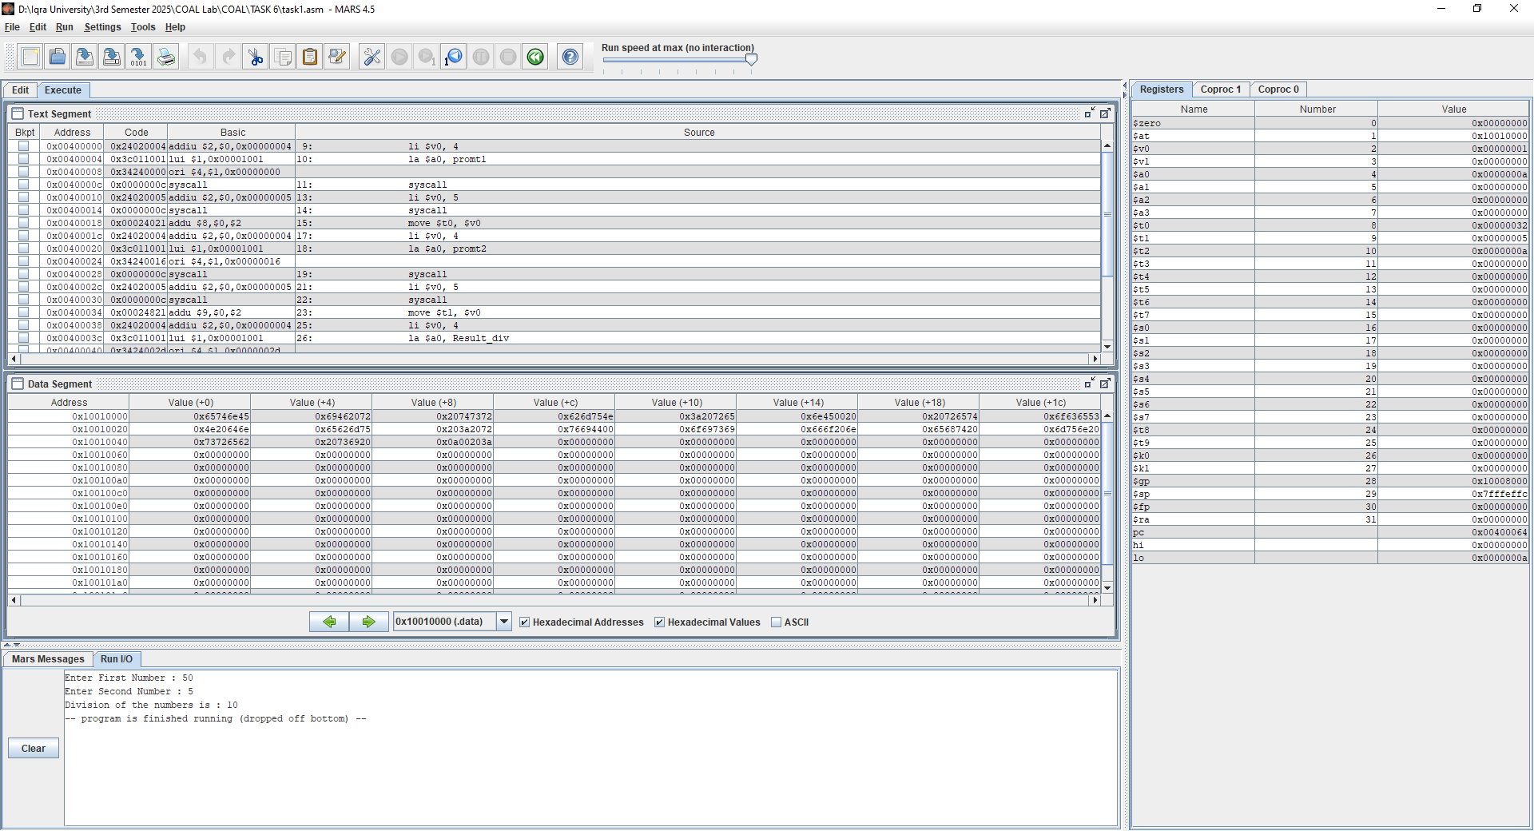.text

main:

li $v0, 4

la $a0, promt1

syscall

li $v0, 5

syscall

move $t0, $v0

li $v0, 4

la $a0, promt2

syscall

li $v0, 5

syscall

move $t1, $v0

li $v0, 4

la $a0, Result_div

syscall

div $t2, $t0, $t1

li $v0, 1

move $a0, $t2

syscall

TASK #02:

.data

promt1: .asciiz "Enter First Number : "

promt2: .asciiz "Enter Second Number : "

promt3: .asciiz "Enter Third Number : "

Result: .asciiz "Division of the numbers is : "

new_line: .asciiz "\n"

.text

main:

li $v0, 4

la $a0, promt1

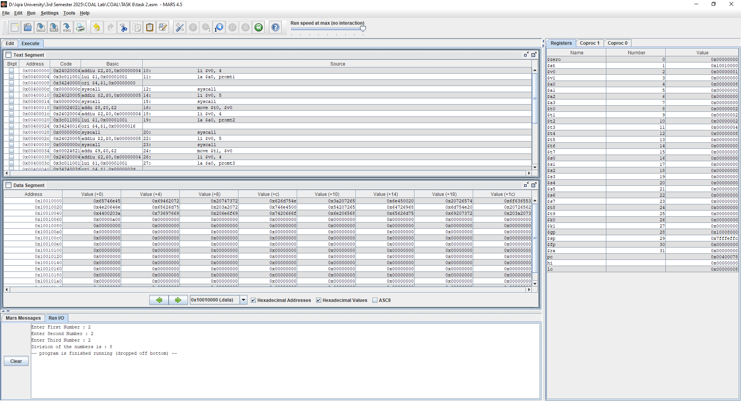 syscall

li $v0, 5

syscall

move $t0, $v0

li $v0, 4

la $a0, promt2

syscall

li $v0, 5

syscall

move $t1, $v0

li $v0, 4

la $a0, promt3

syscall

li $v0, 5

syscall

move $t2, $v0

li $v0, 4

la $a0, Result

syscall

mul $t3, $t1, $t0

mul $t4, $t2, $t3

li $v0, 1

move $a0, $t4

syscall